**1.Create a VM with availability set using the custom image with chrome Pre installed**

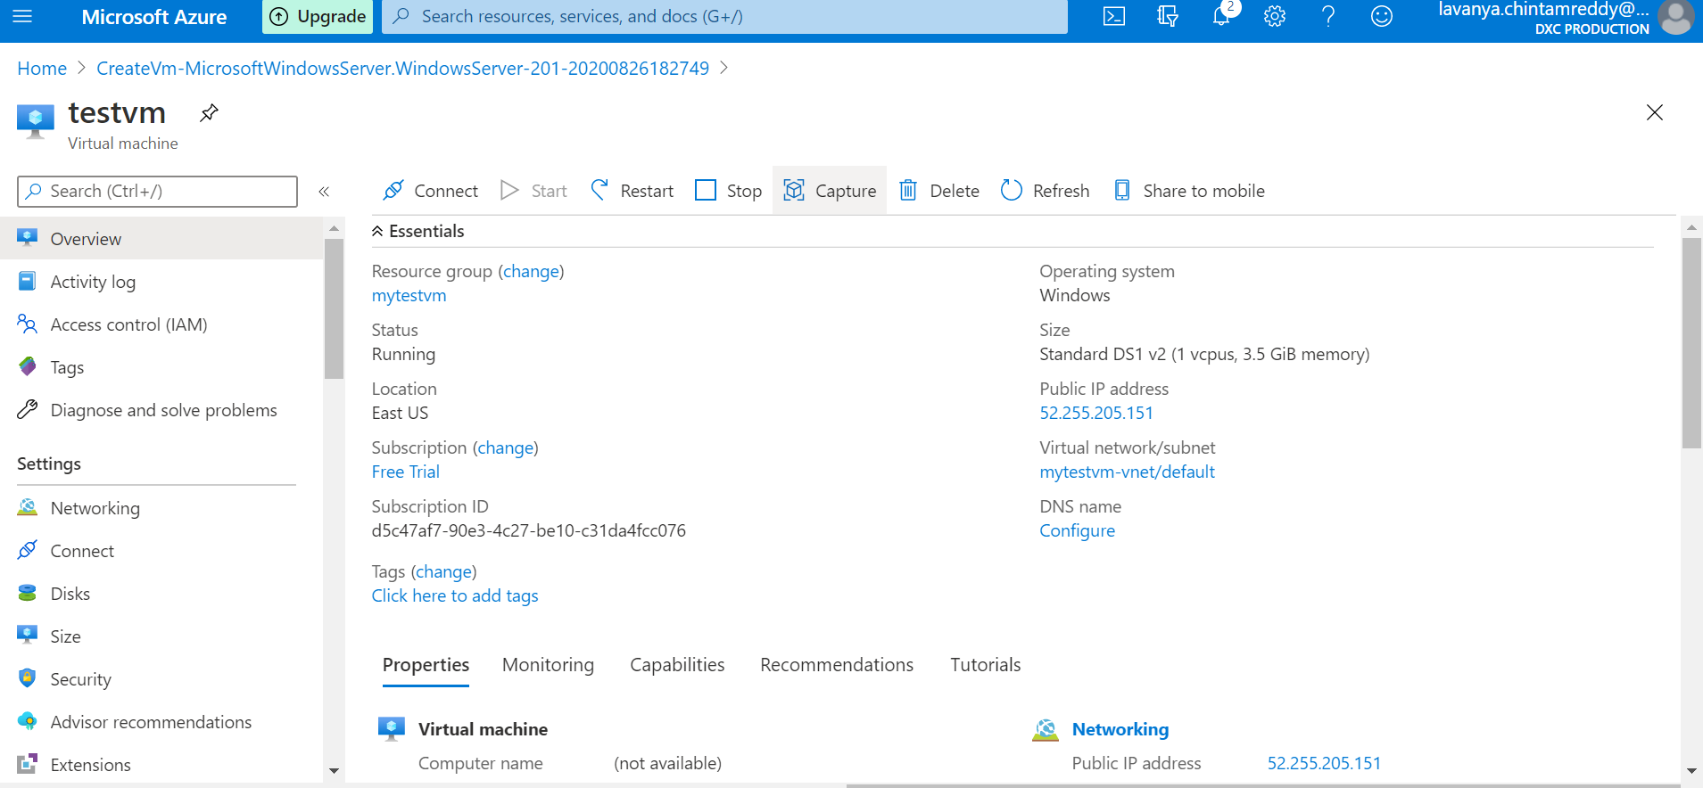

Availability set using custom image

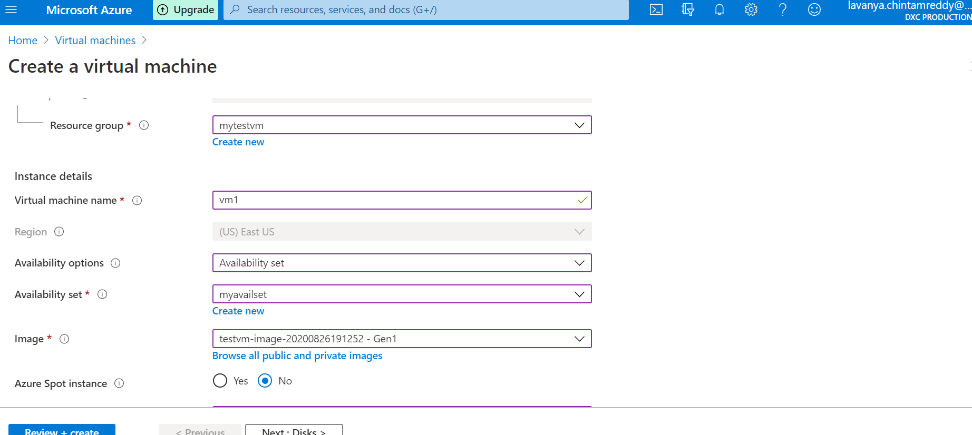

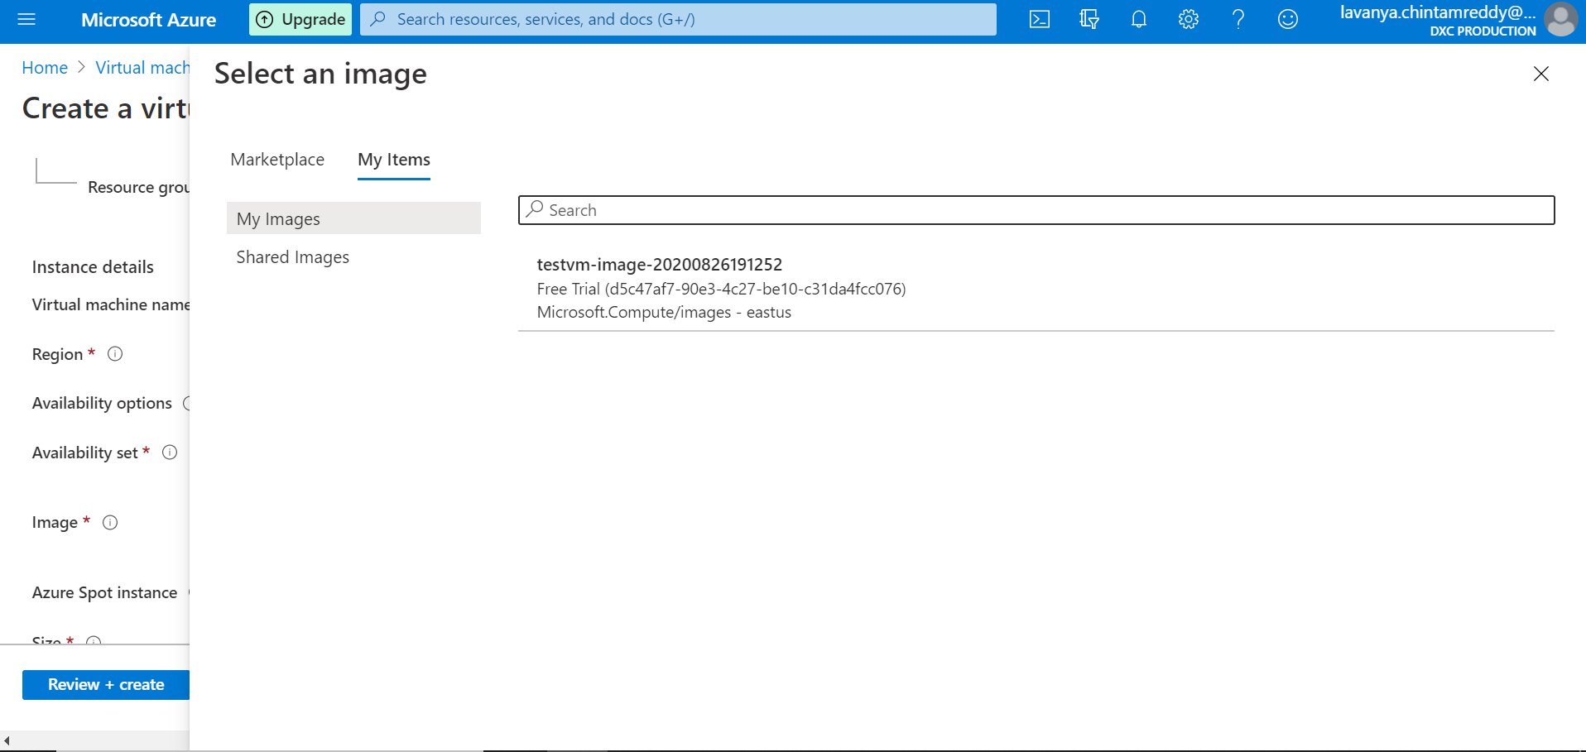

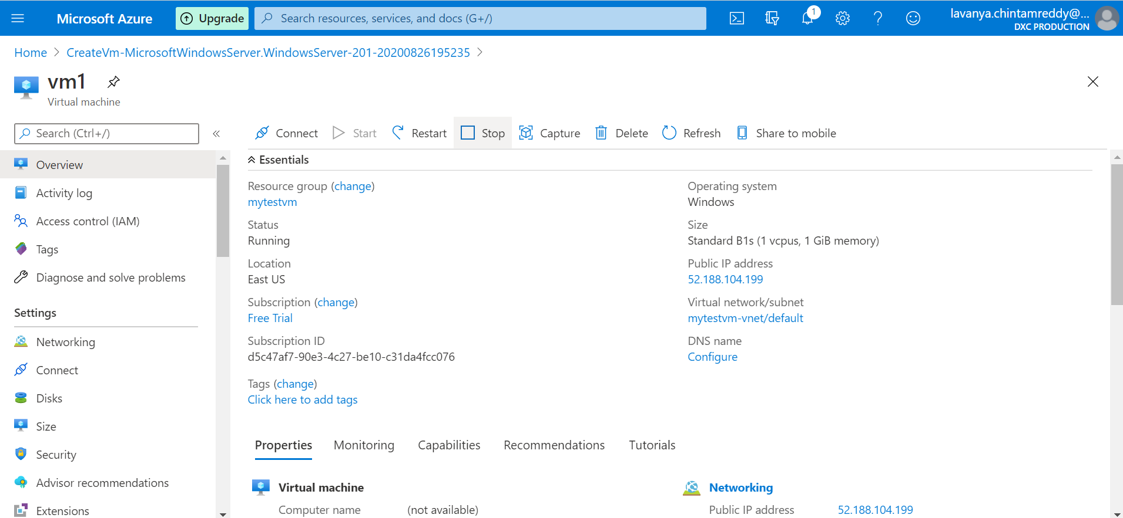

Chrome preinstalled in vm

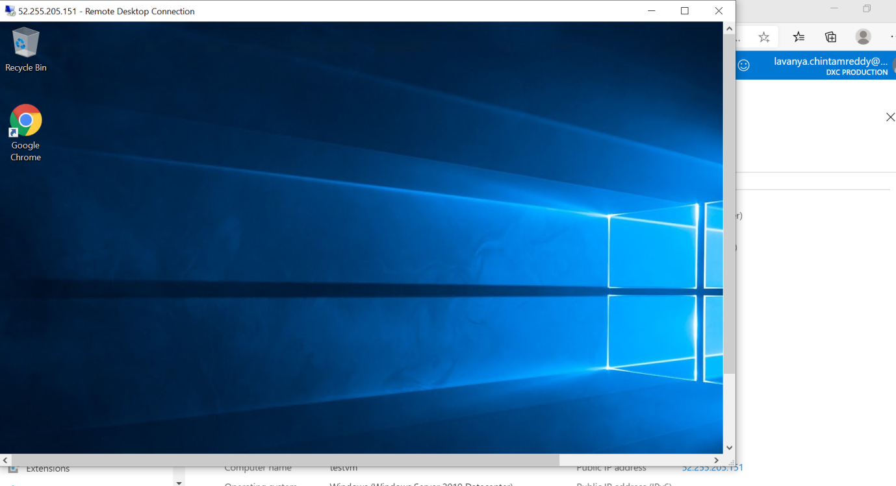

**2.Create a Virtual machine scale set with DS1-v2 standard**

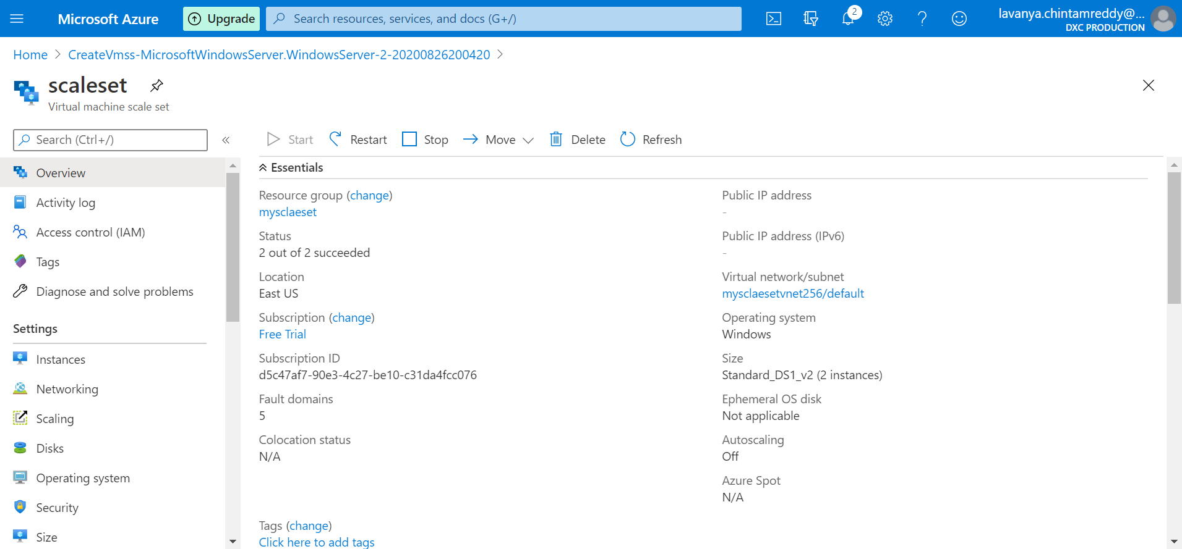

**3.Create a blob storage account with GRS standard and enable the blob soft delete with 15 days retention period also it should be able to connect with Azure storage explorer**

Blob storage account with GRS

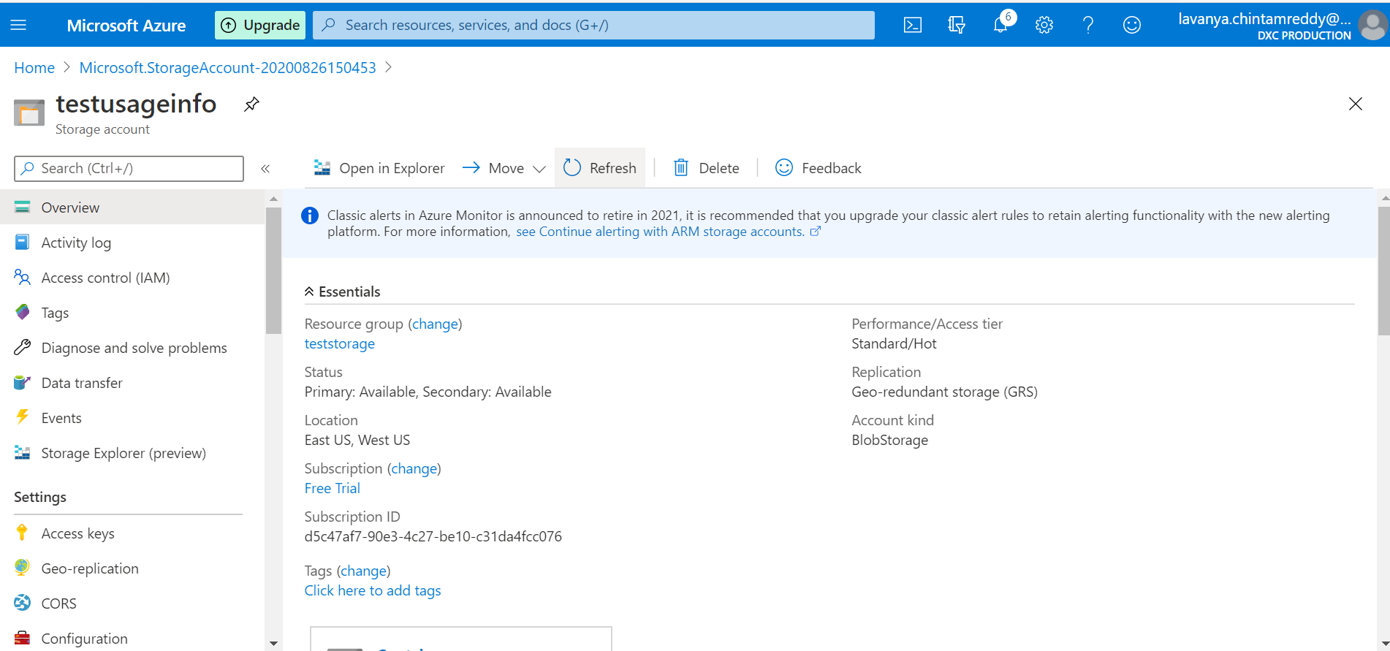

Enable the blob soft delete with 15 days retention period

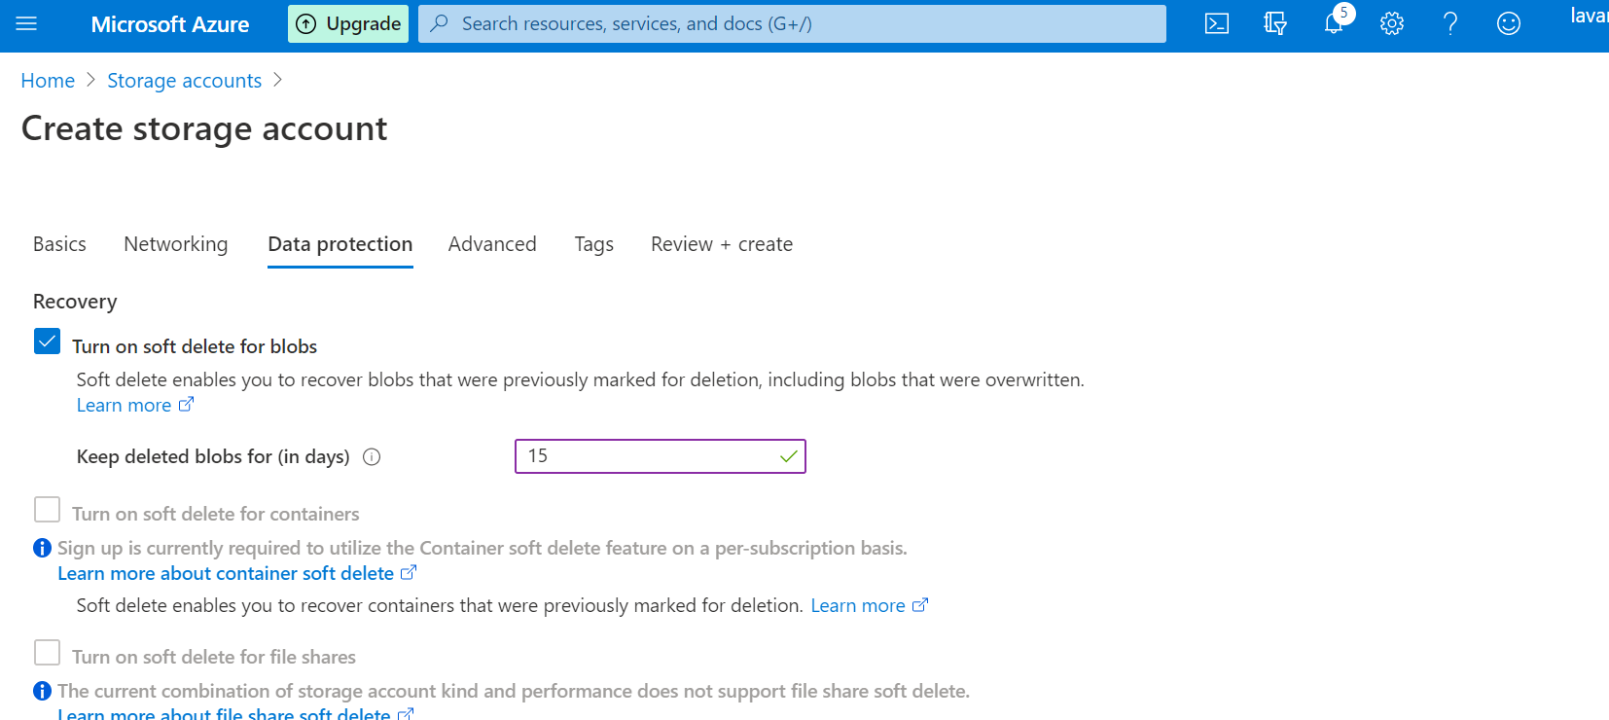

connect with Azure storage explorer

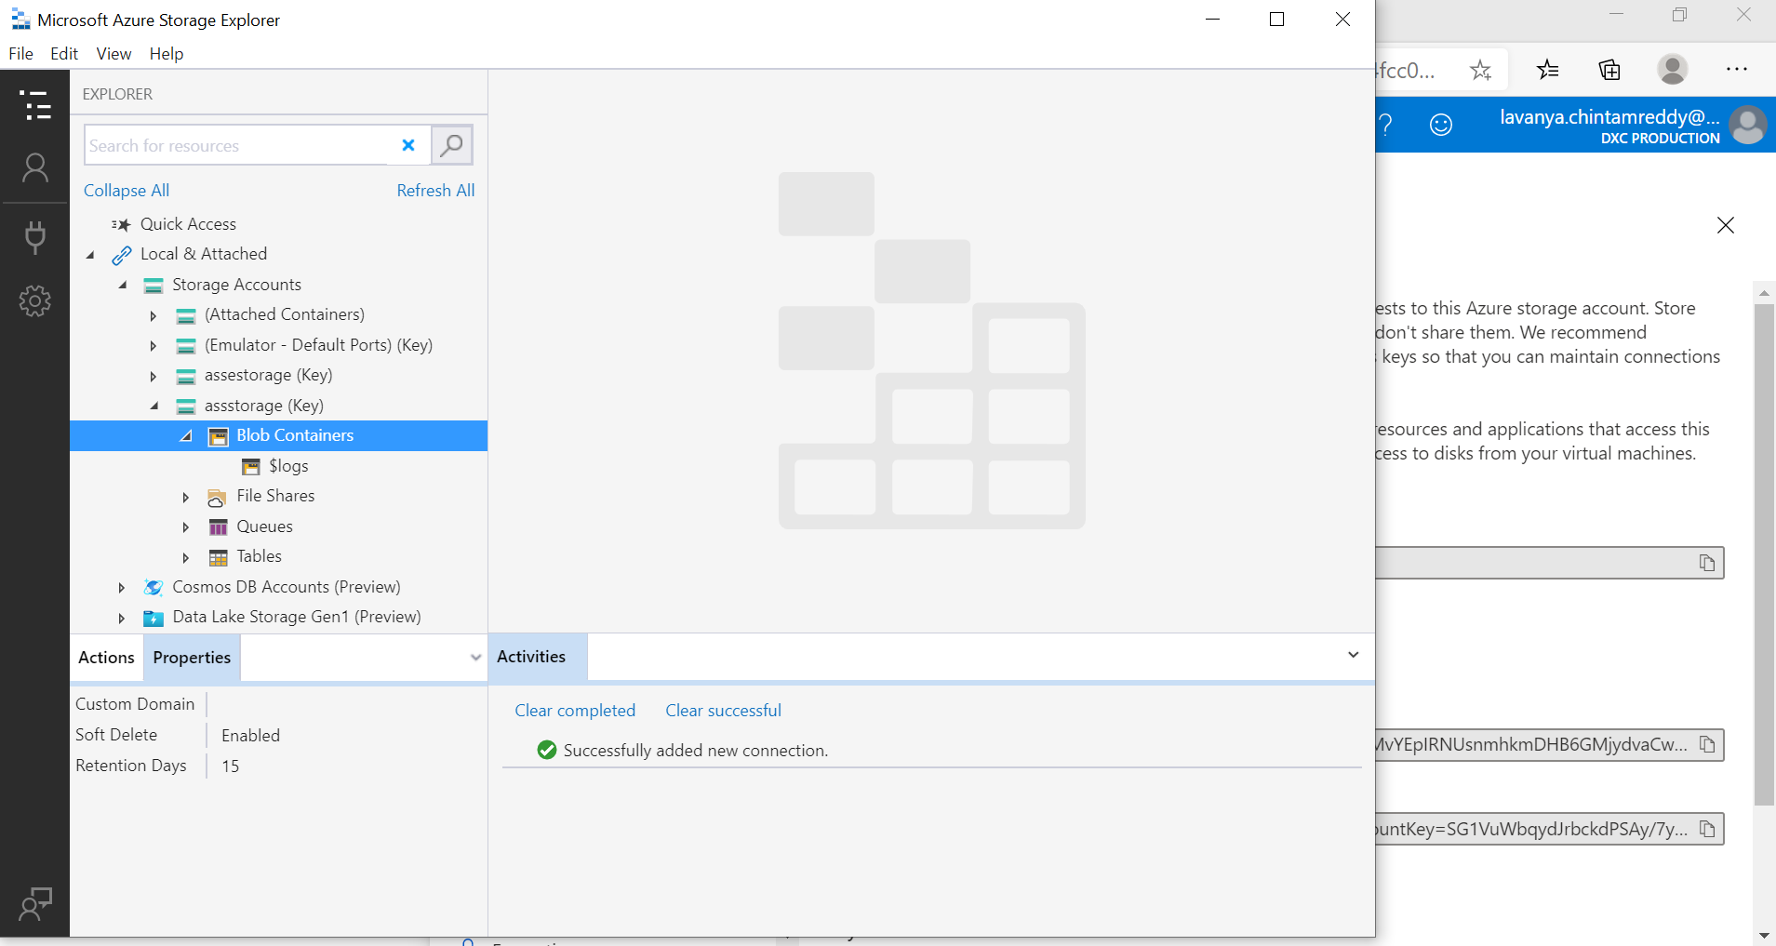

**4.Configure the Vnet and create 3 subnets in the Vnet**

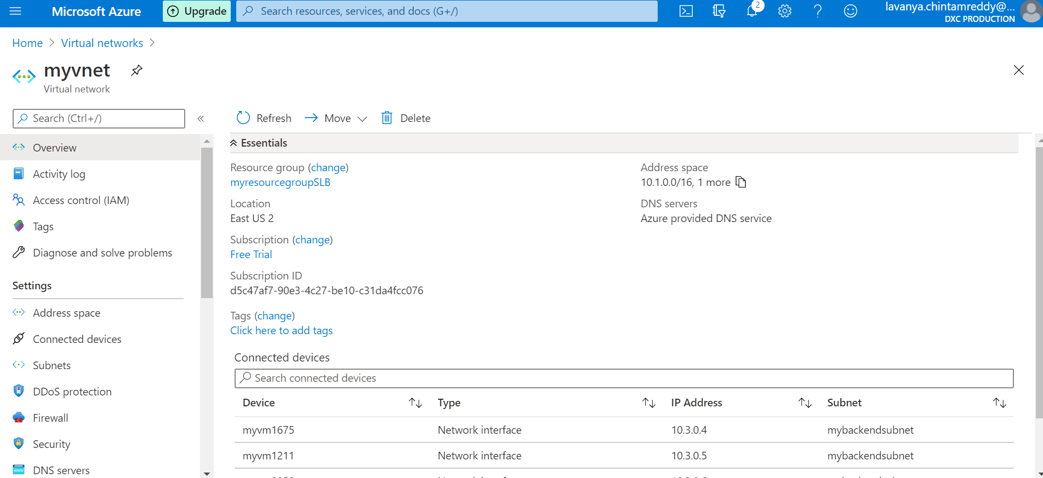

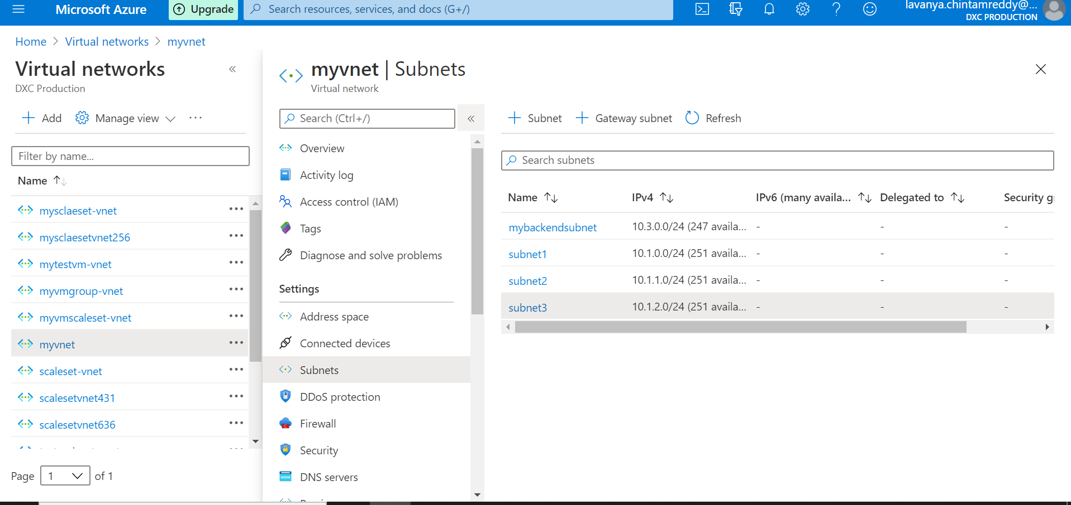

**5.Create a traffic manager with performance routing method**

